

**Tech Saksham**

Case Study Report

Data Analytics with Power BI

|  |  |
| --- | --- |
|  |  |
|  | Trainer Name : UMAMAHESWARI.R |
|  | Master Trainer: UMAMAHESWARI.R |

**“Analysis of Commercial Electricity Consumption in Indian States”**

***THIRUVALLUVAR COLLEGE***

|  |  |
| --- | --- |
| **NM ID** | **NAME** |
| 424FCE01B9C4862A3B04D8EA9A1F1F2C | RATHNA KANNAN.T |

**ABSTRACT**

**This study presents a comprehensive analysis of commercial electricity consumption in insert Indian state name.**

**The study delves into the composition of commercial activities within the state, evaluating the energy intensity of different industries and their contribution to overall consumption. Additionally, the impact of technological advancements, government policies, and infrastructure adequacy on electricity consumption is assessed.**

**INDEX**

|  |  |  |
| --- | --- | --- |
| **Sr. No.** | **Table of Contents** | **Page No.** |
| 1 | Chapter 1: Introduction | 4 |
| 2 | Chapter 2: Services and Tools Required | 6 |
| 3 | Chapter 3: Project Architecture | 7 |
| 4 | Chapter 4: Modeling and Result | 9 |
| 5 | Conclusion | 18 |
| 6 | Future Scope | 19 |
| 7 | References | 20 |
| 8 | Links | 21 |

**CHAPTER 1**

**INTRODUCTION**

* 1. **Problem Statement:**

The problem revolves around the inefficient utilization of electricity in commercial establishments within Insert Indian State Name, leading to various economic,

environmental, and infrastructural issues.

* 1. **Proposed Solution:**

The problem of inefficient electricity utilization in commercial establishments within [Insert Indian State Name] poses significant challenges across economic, environmental, and infrastructural domains. Identifying and addressing this issue is essential for sustainable development and energy security within the state.

Examine the composition of commercial activities in the state. This may include retail, hospitality, manufacturing, IT, healthcare, etc.

Evaluate the energy intensity of different industries and their contribution to overall commercial electricity consumption.

* 1. **Feature:**
* ***Data Collection and Sources:***

This analysis relies on comprehensive data sourced from the state electricity board, government publications, and reputable research organizations.

Historical data spanning multiple years is gathered to discern trends and patterns in commercial electricity consumption.

* ***Consumption Trends and Patterns:***

Analysis of total electricity consumption by commercial establishments reveals trends over time, highlighting periods of growth, stability, or decline.

Seasonal variations and peak demand periods are identified to understand consumption patterns throughout the year.

* 1. **Advantages:**
* ***Technological Advancements:***

Adoption rates of energy-efficient technologies and practices among commercial establishments are evaluated.

The impact of technological advancements, including automation, IoT, and smart building systems, on electricity consumption patterns is examined.

* ***Policy Formulation:***

Analysis of commercial electricity consumption provides policymakers with insights into the effectiveness of existing policies and regulations. It helps in identifying areas where adjustments or new policies are needed to promote energy efficiency, renewable energy adoption, and sustainable practices among commercial establishments.

* ***Economic Planning:***

Commercial electricity consumption data is closely linked to economic activity. Analyzing consumption trends helps in forecasting economic growth, identifying emerging sectors, and assessing the overall health of the economy. This information is invaluable for economic planning and investment decision-making.

* 1. **Scope:**
* ***Economic Impact:***

Assessment of the economic implications of commercial electricity consumption on businesses, consumers, and the overall economy**.**

Estimation of the cost savings potential through energy efficiency measures and renewable energy adoption.

* ***Environmental Impact:***

Quantification of carbon emissions and other environmental footprints associated with commercial electricity consumption.

Identification of strategies to reduce environmental impact and promote sustainable practices

**CHAPTER 2**

**SERVICES AND TOOLS REQUIRED**

**2.1 Services Used:**

* ***Data Collection and Analysis Services:***

Services for collecting and analyzing electricity consumption data from state electricity boards, government agencies, and other relevant sources.

Statistical analysis tools and software for processing large datasets, identifying trends, and generating insights.

* ***Geospatial Analysis Services:***

Geospatial mapping services to visualize and analyze the distribution of commercial establishments and electricity consumption patterns across different regions.

eographic Information System (GIS) software for spatial analysis, identifying hotspots, and assessing infrastructure needs.

**2.2 Tools and Software used**

***Tools;***

* Energy monitoring and metering systems to track electricity consumption in real-time for individual commercial establishments.
* Smart metering technology for capturing granular consumption data and detecting anomalies or inefficiencies.
* **Power BI**: The main tool for this project is Power BI, which will be used to create interactive dashboards for real-time data visualization.
* **Power Query**: This is a data connection technology that enables you to discover, connect, combine, and refine data across a wide variety of sources.
* **Software Requirements**:
* **Power BI Desktop**: This is a Windows application that you can use to create reports and publish them to Power BI.
* **Power BI Service**: This is an online SaaS (Software as a Service) service that you use to publish reports, create new dashboards, and share insights.
* **Power BI Mobile**: This is a mobile application that you can use to access your reports and dashboards on the go.

:

**HAPTER 3**

**PROJECT ARCHITECTURE**

**3.1 Architecture**

**USER FRONTEND BACKEND**

|  |  |  |
| --- | --- | --- |
|  | **HTML 5** | **NODEJS 14.0**  **Database** |

* ***Data Visualization and Reporting Tools;***
  + Data visualization tools and software for creating dashboards, charts, and reports to communicate key findings and insights from the analysis.
  + Tools for generating interactive maps, graphs, and infographics to present consumption trends, patterns, and recommendations effectively.
* ***Geospatial Analysis Services:***
  + Geospatial mapping services to visualize and analyze the distribution of commercial establishments and electricity consumption patterns across different regions.
  + Geographic Information System (GIS) software for spatial analysis, identifying hotspots, and assessing infrastructure needs.
* ***Energy Monitoring and Metering Tools;***
  + Energy monitoring and metering systems to track electricity consumption in real-time for individual commercial establishments.
  + Smart metering technology for capturing granular consumption data and detecting anomalies or inefficiencies.
* ***Energy Audit Services*;**
  + Energy audit services to assess the energy performance of commercial buildings and identify opportunities for energy efficiency improvements.
  + Certified energy auditors and engineers equipped with measurement tools and software for conducting comprehensive audits.
* ***Data Collection*:**

Gather data on commercial electricity consumption from reliable sources such as the state electricity board, government reports, or independent research organizations.

Collect historical data spanning several years to identify trends and patterns.

**CHAPTER 4**

**MODELING AND RESULT**

**Manage relationship**

* Clearly define the objectives of the modeling exercise, such as understanding consumption patterns, forecasting future demand, or evaluating the impact of policy interventions.
* Ensure alignment with stakeholders' goals and priorities to guide the modeling process effectively.

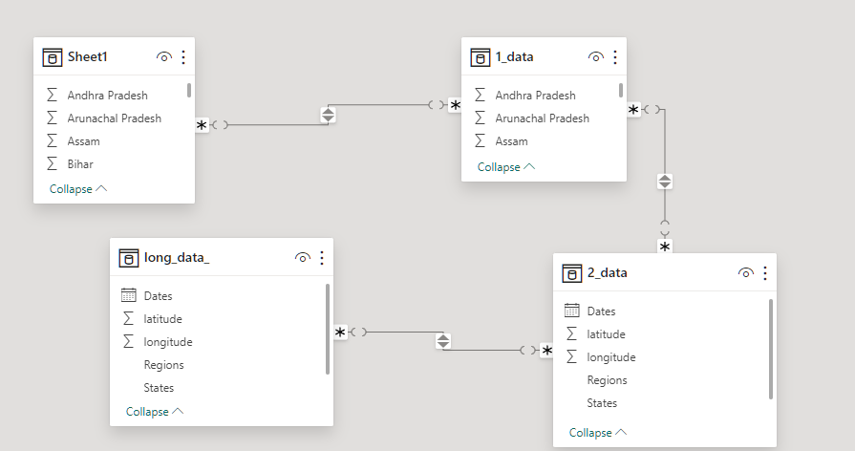

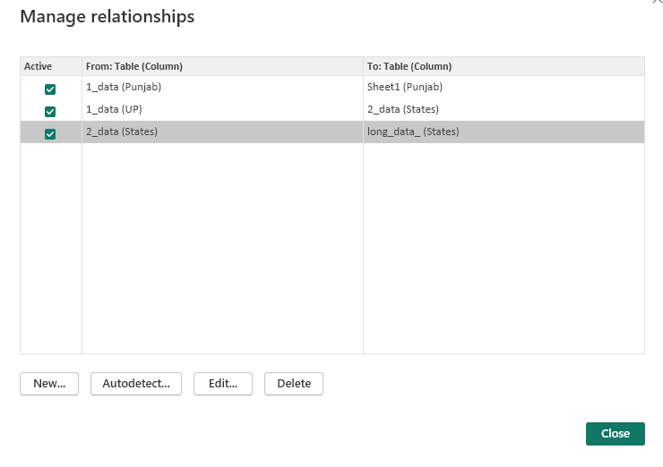

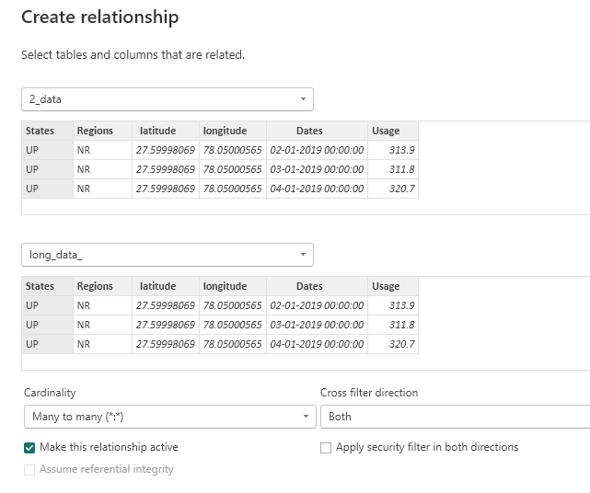

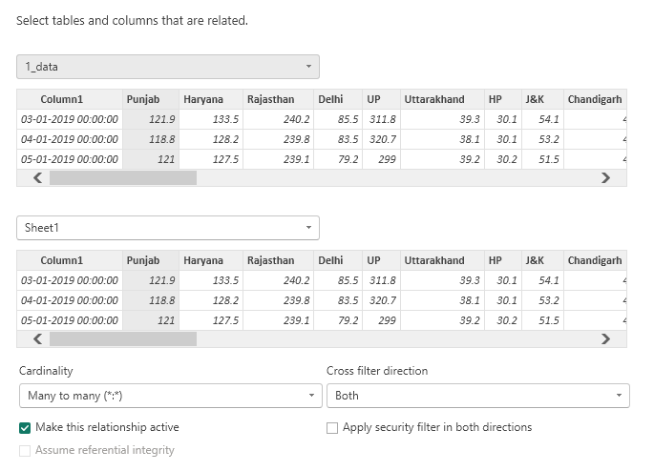

***Modelling for state and region***

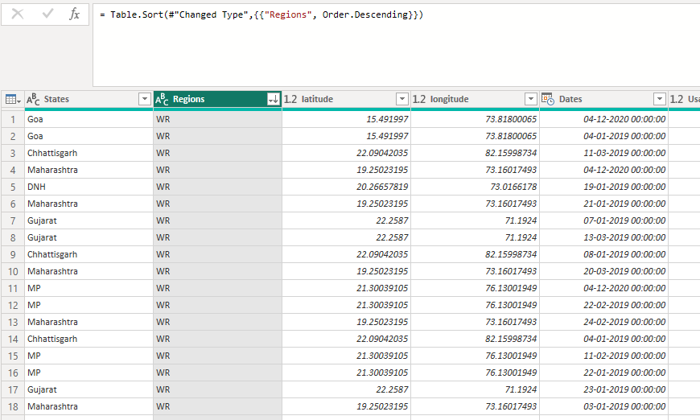

***Replacing values ;***

Set some fields to English for easy understanding, we replace values to English with the Power Query Editor.

Changing the order of Region name at Power Query

Duplicate the “district /region” then split column using space as delimiter.

Then merge column by Region and direction. Refer to applied steps for details.

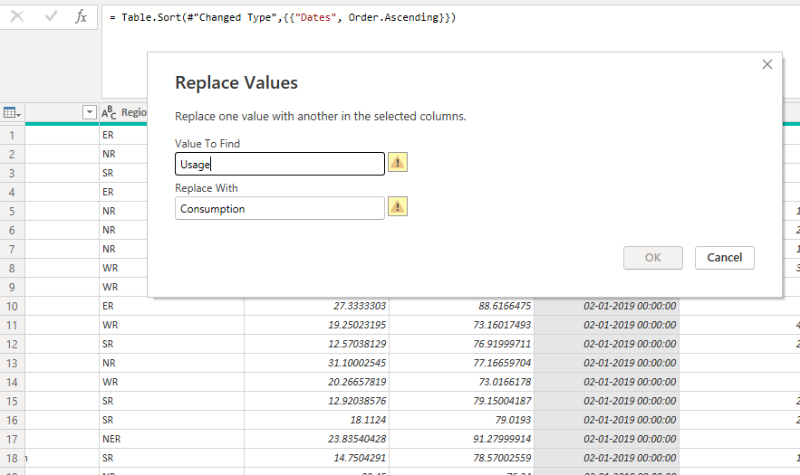

**Group by;**

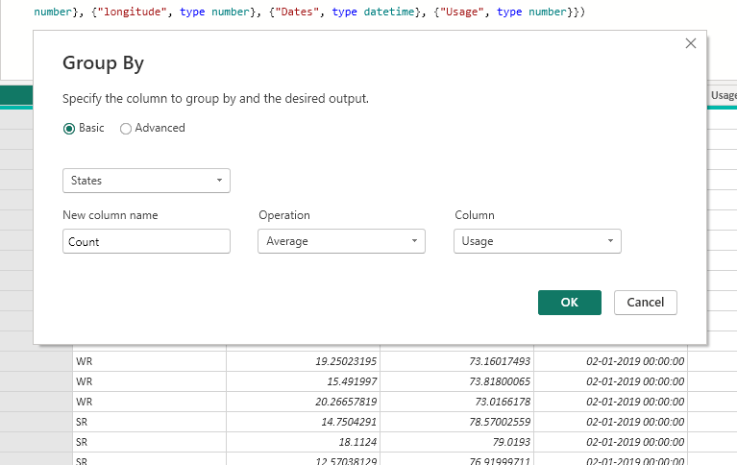

**Dashboard;**

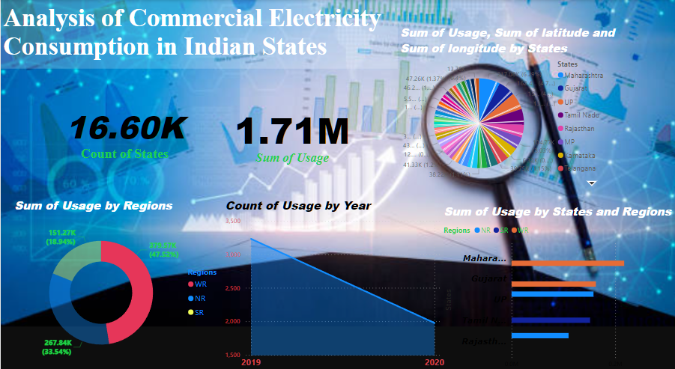

***CONCLUSION***

The analysis of commercial electricity consumption in India provides valuable insights into the dynamics, challenges, and opportunities in managing energy usage within the commercial sector.

Despite the challenges, the analysis identifies several opportunities for improvement in managing commercial electricity consumption. These include:

* Implementing energy efficiency measures and technologies to reduce wastage and optimize consumption.
* Encouraging the adoption of renewable energy sources to diversify the energy mix and reduce carbon emissions.
* The conclusion emphasizes the importance of continuous monitoring, evaluation, and improvement in managing commercial electricity consumption.
* In conclusion, the analysis underscores the critical role of efficient electricity utilization in driving sustainable development, economic growth, and environmental stewardship in India. By addressing the identified challenges, leveraging opportunities, and fostering collaboration among stakeholders, India can achieve a more resilient, equitable, and sustainable energy future for the commercial sector.

Top of Form

**FUTURE SCOPE;**

As technology evolves and new challenges emerge, the analysis of commercial electricity consumption in India presents several avenues for future exploration and improvement:

**1. Advanced Modeling Techniques:**

* Integration of advanced modeling techniques such as machine learning, artificial intelligence, and big data analytics to enhance predictive capabilities and accuracy in forecasting commercial electricity consumption.
* Incorporation of real-time data streams and IoT sensors for dynamic modeling of consumption patterns and demand response strategies.

**2. Smart Grid Integration:**

* Exploration of smart grid technologies and solutions to optimize electricity distribution, manage peak demand, and enhance grid reliability in commercial areas.
* Integration of smart meters, energy management systems, and automated controls for real-time monitoring and control of electricity usage.

**3. Energy Storage Solutions:**

* Investigation of energy storage solutions such as battery storage, pumped hydro, and thermal storage to address intermittency and variability in renewable energy generation.
* Deployment of energy storage systems to support grid stability, load balancing, and peak shaving in commercial establishments

**REFERENCES**

<https://m.economictimes.com/industry/energy/power/indias-power-consumption-grows-nearly-8-pc-to-847-billion-units-in-first-half-of-fy24/articleshow/104254849.cms>

**link**